HW1: Mid-term assignment report

*Ana Alexandra Antunes [876543]*, v2021-04-27

1 Introduction 1

1.1 Overview of the work 1

1.2 Current limitations 1

2 Product specification 1

2.1 Functional scope and supported interactions 1

2.2 System architecture 2

2.3 API for developers 2

3 Quality assurance 2

3.1 Overall strategy for testing 2

3.2 Unit and integration testing 2

3.3 Functional testing 2

3.4 Static code analysis 2

3.5 Continuous integration pipeline [optional] 3

4 References & resources 3

# Introduction

## Overview of the work

This report presents the midterm individual project required for TQS, covering both the software product features and the adopted quality assurance strategy.

<briefly introduce your application: name the product, if applicable; what is its purpose?>

## Current limitations

 <explain the known limitations/unimplemented (yet expected) features>

# Product specification

## Functional scope and supported interactions

<functional (black-box) description of the application: how will the actors interact the application? For what? (explain the main **scenarios** of usage**)**>

## System architecture

<briefly present the software architecture. Include one or more diagrams.>

<detail the specific technologies/frameworks that were used>

## API for developers

<what services/resources can a developer obtain from your project? document your API endpoints>

<note: for the homework, you are expected to expose two “groups” of endpoints:

* Problem domain: get the forecast by region, etc.
* Cache usage statistics: how many hits/misses,… >

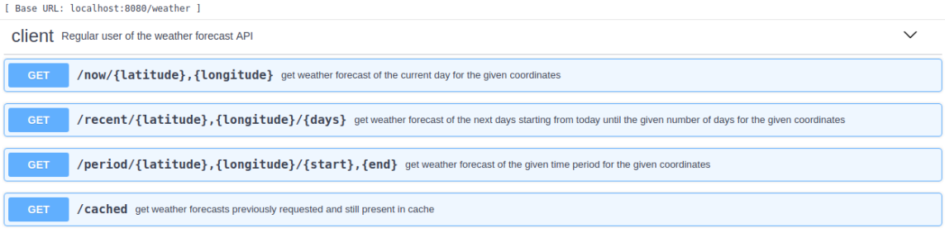

# Quality assurance

## Overall strategy for testing

[what was the overall test development strategy? E.g.: did you do TDD? Did you choose to use Cucumber and BDD? Did you mix different testing tools, like REST-Assured and Cucumber?...]

## Unit and integration testing

[which test cases did you considered? How were they implemented?]

[may add some screenshots/code snippets for clarification]

## Functional testing

[which test cases did you considered? How were they implemented?]

[may add some screenshots/code snippets]

## Static code analysis

[which tools/workflow was used to for static code analysis? Show and interpret the results. ]

[you may add some interesting lessons learned, e.g., some code smell reported by the tool that was difficult to spot and otherwise you wouldn’t address it]

## Continuous integration pipeline [optional]

[did you implement a CI pipeline? What was the setup? Illustrate with screenshots, if applicable]

# References & resources

Project resources

* Video demo [where did you place a short video demonstration of your solution; should be in the Git repository]
* Ready to use application: [**optional**; if you have the solution deployed in a public server, place the URL here]
* QA dashboard: [**optional**; if you have a quality dashboard available (e.g.: sonarcloud), place the URL here]

Reference materials

<document the key components (e.g.: libraries, API) or key references (e.g.: blog post) that were helpful and certainly would help other students pursuing a similar work>